Name: Class:
Introduction
The chloro-alkali industry produces two of the most important chemicals in the world: chlorine (Cl₂) and caustic soda, sodium hydroxide (NaOH). Chlorine is used mainly for the production of plastics such as PVC and other organic chemicals. It is also used for the disinfection of water supplies and in the paper industry for bleaching. Sodium hydroxide is used to make many organic and inorganic compounds. It is also used in a number of industries, including the paper industry.
Chlorine and sodium hydroxide are produced from the electrolysis of brine, concentrated sodium chloride solution. Three different types of cells, the diaphragm cell, the mercury cell and the membrane cell, have been used for this production. The membrane cell is now the preferred cell because the diaphragm cell uses asbestos and the mercury cell releases mercury into the environment. Comparatively, the membrane cell is a clean process, although the electricity it consumes often comes from fossil fuels and so the process contributes to greenhouse gas emissions. A simplified diagram of a membrane cell is shown below.

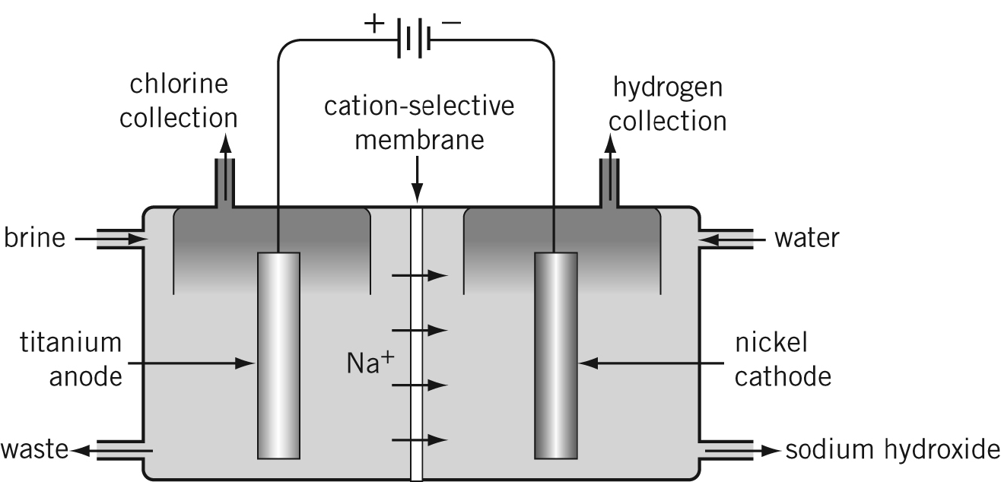

No. | Question | Answer
a Write the half-equation for the reaction that must be occurring at the negative electrode (cathode).
b Write the half-equation for the reaction that must be occurring at the positive electrode (anode).
c Write the overall equation for the membrane cell reaction.

 | If 1.0 tonne of NaCl is consumed, what volume of chlorine, measured at 101.3 kPa and 0ºC, could be produced?
a Water is a stronger reductant than chloride ions. Therefore, what are the expected products at the anode?
b Propose a reason why the predicted substances are not produced.
 | Sodium metal is not produced in this cell. Explain why.
 | The polymer membrane is constructed so that only cations can pass through. Explain the advantages of this design.
 | The left-hand anode compartment is filled continuously with brine, while the right-hand cathode compartment is filled continuously with water. Why are different liquids required?
The concentration of the sodium hydroxide produced is about 30% m/m. It needs to be at least 50% m/m to be sold.
a How could this be achieved?
b How might this affect the cost of the products?
 | Hydrogen is another product of the membrane cell. State one use of hydrogen gas.

